附录：测量数据及数据处理例子
实验时间：2021-2-28 实验条件：室温15.6℃
常温实验：温度不变，（体积V由大到小），验证体积V与压强P的关系
序号 | 1 | 2 | 3 | 4 | 5 | 6 | 7 | 8 | 9 | 10
读数体积（mL) | 180 | 175 | 170 | 165 | 160 | 155 | 150 | 145 | 140 | 135
标准大气压P(Kpa) | 101.325 | 101.325 | 101.325 | 101.325 | 101.325 | 101.325 | 101.325 | 101.325 | 101.325 | 101.325
读数压强P(Kpa) | 3.05 | 5.95 | 8.9 | 12.08 | 15.41 | 18.97 | 22.73 | 26.8 | 30.99 | 35.81
压强P(Kpa) | 104.375 | 107.275 | 110.225 | 113.405 | 116.735 | 120.295 | 124.055 | 128.125 | 132.315 | 137.135
1/p (kPa-1) | 9.58 | 9.32 | 9.07 | 8.82 | 8.57 | 8.31 | 8.06 | 7.80 | 7.56 | 7.29
序号 | 11 | 12 | 13 | 14 | 15 | 16 | 17 | 18 | 19
读数体积（mL) | 130 | 125 | 120 | 115 | 110 | 105 | 100 | 95 | 90
大气压强P(Kpa) | 101.325 | 101.325 | 101.325 | 101.325 | 101.325 | 101.325 | 101.325 | 101.325 | 101.325
读数压强P(Kpa) | 40.89 | 46.2 | 52.2 | 58.35 | 65.28 | 72.74 | 81.25 | 90.43 | 100.2
压强P(Kpa) | 142.215 | 147.525 | 153.525 | 159.675 | 166.605 | 174.065 | 182.575 | 191.755 | 201.525
1/p (kPa-1) | 7.03 | 6.78 | 6.51 | 6.26 | 6.00 | 5.74 | 5.48 | 5.21 | 4.96

根据表格数据绘制关系曲线如图1：

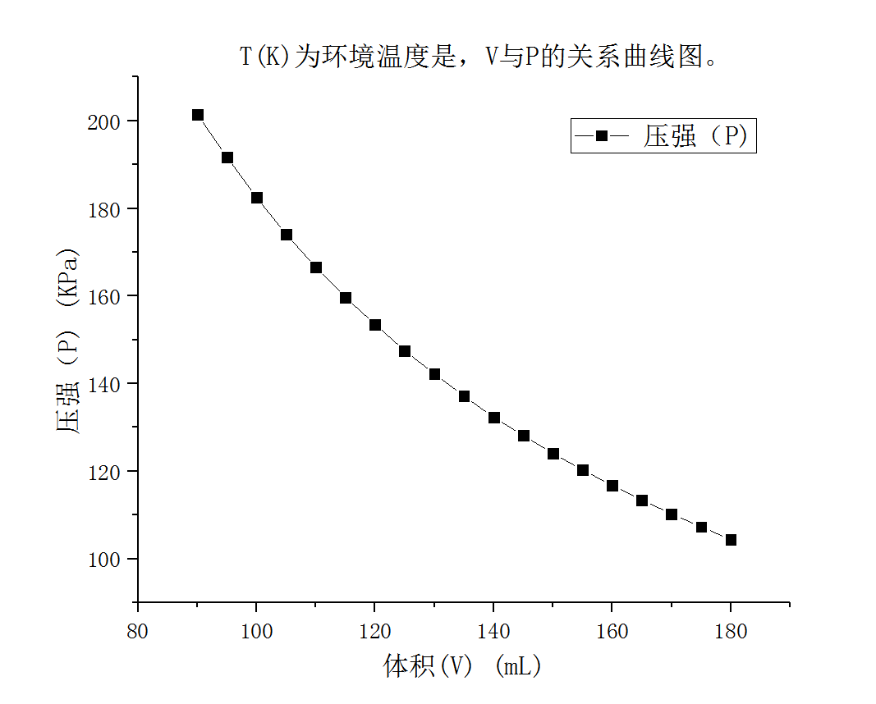
图1

根据表格数据绘制V'-1/p关系曲线如图：

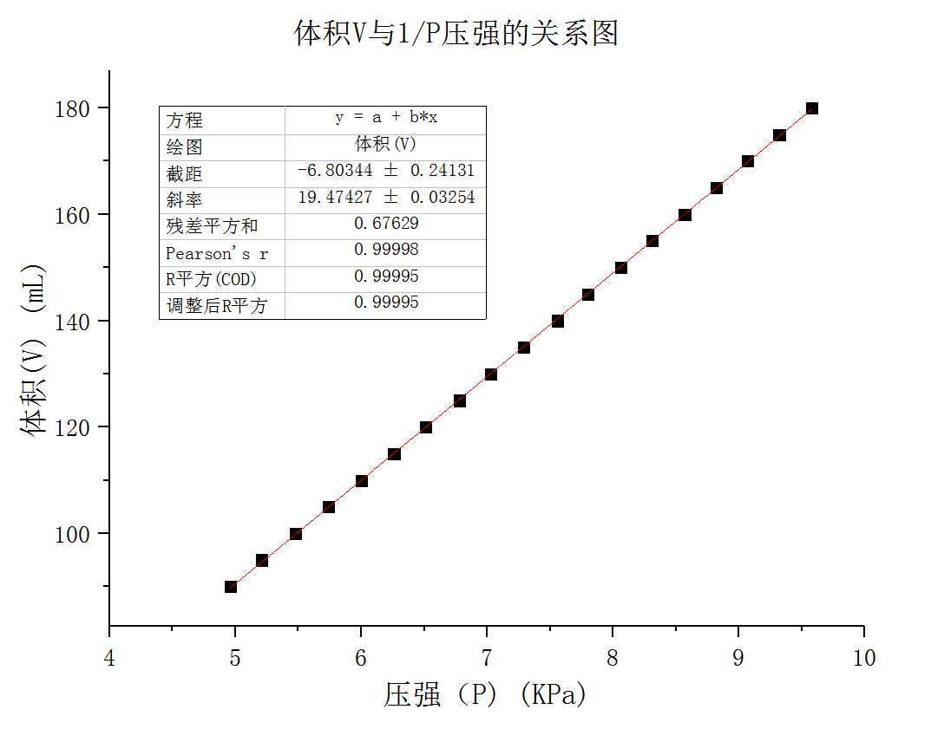

由图可知，在同一温度下，V'与1/p近似成线性关系，验证了波义耳-马略特定律。
- 用直线拟合该曲线并得到纵坐标截距V₀，V₀即是由于结构原因无法准确给出的密封气体的体积零差。直线斜率即为nRT，根据温度T（绝对温度）和R的参考值，计算出密封气体的物质的量n。
由图可知，线性拟合直线的斜率k₁=nRT=19474 mJ。已知参考值R=8.31 J/(mol∙K)，T=15.6. ℃（即288.75 K），可以计算出密封气体的物质的量为n=8.11 mmol。
同时根据拟合直线的截距可知气体体积零差V₀=6.8mL。

附表 2 同一体积下，测量气体压强与温度的关系

（升温）实验： 体积不变、 温度由室温，加热到65℃。
读数体积 | 180mL
序号 | 1 | 2 | 3 | 4 | 5 | 6 | 7 | 8 | 9 | 10 | 11
温度T (℃) | 15.3 | 17 | 19 | 21 | 23 | 25 | 27 | 29 | 31 | 33 | 35
T0（k) | 273.15 | 273.15 | 273.15 | 273.15 | 273.15 | 273.15 | 273.15 | 273.15 | 273.15 | 273.15 | 273.15
温度T (K) | 288.45 | 290.15 | 292.15 | 294.15 | 296.15 | 298.15 | 300.15 | 302.15 | 304.15 | 306.15 | 308.15
大气压强p (kPa) | 101.325 | 101.325 | 101.325 | 101.325 | 101.325 | 101.325 | 101.325 | 101.325 | 101.325 | 101.325 | 101.325
读数压强p (kPa) | 2.97 | 6.11 | 7.85 | 9.05 | 10.1 | 11.05 | 11.96 | 12.77 | 13.61 | 14.38 | 15.14
压强p (kPa) | 104.295 | 107.435 | 109.175 | 110.375 | 111.425 | 112.375 | 113.285 | 114.095 | 114.935 | 115.705 | 116.465
序号 | 12 | 13 | 14 | 15 | 16 | 17 | 18 | 19 | 20 | 21 | 22
温度T (℃) | 37 | 39 | 41 | 43 | 45 | 47 | 49 | 51 | 53 | 55 | 57
T0（k) | 273.15 | 273.15 | 273.15 | 273.15 | 273.15 | 273.15 | 273.15 | 273.15 | 273.15 | 273.15 | 273.15
温度T (K) | 310.15 | 312.15 | 314.15 | 316.15 | 318.15 | 320.15 | 322.15 | 324.15 | 326.15 | 328.15 | 330.15
大气压强p (kPa) | 101.325 | 101.325 | 101.325 | 101.325 | 101.325 | 101.325 | 101.325 | 101.325 | 101.325 | 101.325 | 101.325
读数压强p (kPa) | 15.93 | 16.61 | 17.37 | 18.14 | 18.92 | 19.61 | 20.43 | 21.22 | 22.07 | 22.89 | 23.78
压强p (kPa) | 117.255 | 117.935 | 118.695 | 119.465 | 120.245 | 120.935 | 121.755 | 122.545 | 123.395 | 124.215 | 125.105
序号 | 23 | 24 | 25 | 26
温度T (℃) | 59 | 61 | 63 | 65
T0（k) | 273.15 | 273.15 | 273.15 | 273.15
温度T (K) | 332.15 | 334.15 | 336.15 | 338.15
大气压强p (kPa) | 101.325 | 101.325 | 101.325 | 101.325
读数压强p (kPa) | 24.67 | 25.66 | 26.69 | 27.89
压强p (kPa) | 125.995 | 126.985 | 128.015 | 129.215

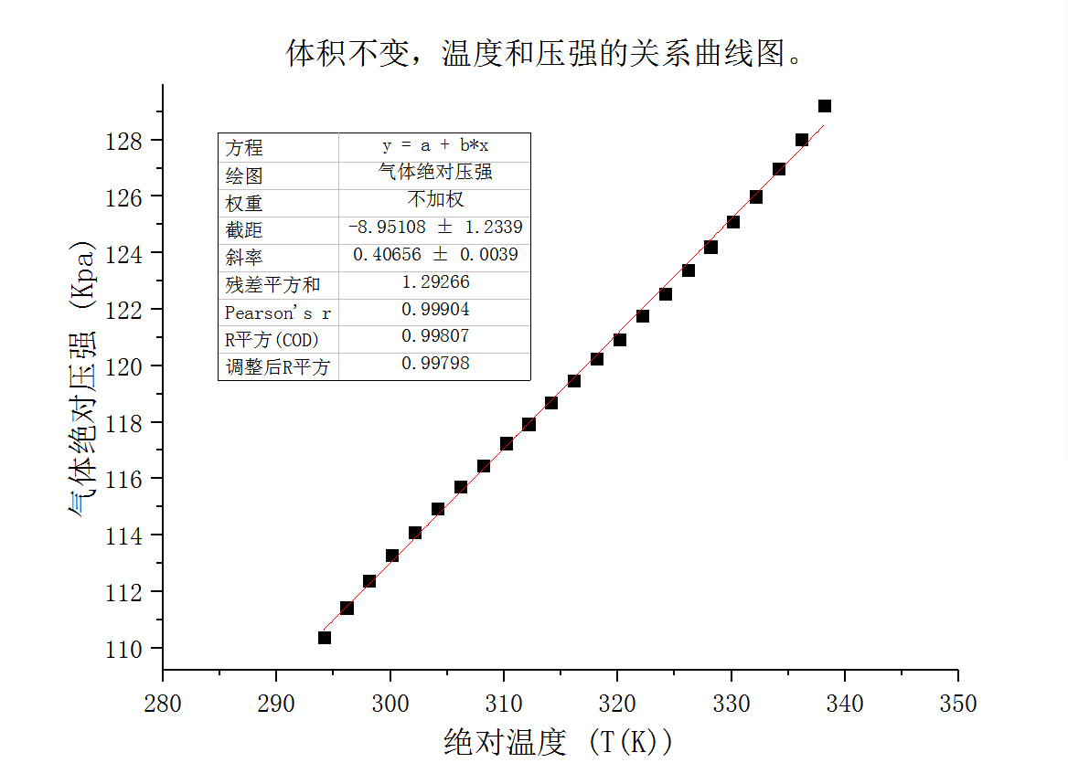

由图可知，在同一体积下，p与T近似成线性关系，验证了查理定律。

由图可知，线性拟合直线的斜率k=nR/(V'+V₀)=0.40656 kPa/K。已知n=8.11 mmol，V'+V₀=180+（-8.95）=171.05(mL)，可得R及其与参考值的相对误差：R=KV/n=8.56 J/(mol∙K)，相对误差3.1%。

（降温）实验： 体积不变、 温度加热到64℃、从64℃连续降温至常温，观察T与p的关系
体积 | 180mL
序号 | 1 | 2 | 3 | 4 | 5 | 6 | 7 | 8 | 9 | 10 | 11
温度T (℃) | 64 | 63 | 61 | 59 | 57 | 55 | 53 | 51 | 49 | 47 | 45
T0（k) | 273.15 | 273.15 | 273.15 | 273.15 | 273.15 | 273.15 | 273.15 | 273.15 | 273.15 | 273.15 | 273.15
温度T (K) | 337.15 | 336.15 | 334.15 | 332.15 | 330.15 | 328.15 | 326.15 | 324.15 | 322.15 | 320.15 | 318.15
大气压强p (kPa) | 101.325 | 101.325 | 101.325 | 101.325 | 101.325 | 101.325 | 101.325 | 101.325 | 101.325 | 101.325 | 101.325
读数压强p (kPa) | 27.23 | 23.76 | 22.11 | 20.83 | 19.68 | 18.66 | 17.6 | 16.65 | 15.78 | 14.8 | 13.9
压强p (kPa) | 128.555 | 125.085 | 123.435 | 122.155 | 121.005 | 119.985 | 118.925 | 117.975 | 117.105 | 116.125 | 115.225
序号 | 12 | 13 | 14 | 15 | 16 | 17 | 18 | 19 | 20 | 21 | 22
温度T (℃) | 43 | 41 | 39 | 37 | 35 | 33 | 31 | 29 | 27 | 25 | 23
T0（k) | 273.15 | 273.15 | 273.15 | 273.15 | 273.15 | 273.15 | 273.15 | 273.15 | 273.15 | 273.15 | 273.15
温度T (K) | 316.15 | 314.15 | 312.15 | 310.15 | 308.15 | 306.15 | 304.15 | 302.15 | 300.15 | 298.15 | 296.15
大气压强p (kPa) | 101.325 | 101.325 | 101.325 | 101.325 | 101.325 | 101.325 | 101.325 | 101.325 | 101.325 | 101.325 | 101.325
读数压强p (kPa) | 13 | 12.02 | 10.99 | 9.96 | 9.05 | 8.12 | 7.25 | 6.44 | 5.64 | 4.87 | 4.15
压强p (kPa) | 114.325 | 113.345 | 112.315 | 111.285 | 110.375 | 109.445 | 108.575 | 107.765 | 106.965 | 106.195 | 105.475
序号 | 23 | 24 | 25 | 26
温度T (℃) | 21 | 19 | 17 | 15
T0（k) | 273.15 | 273.15 | 273.15 | 273.15
温度T (K) | 294.15 | 292.15 | 290.15 | 288.15
读数压强p (kPa) | 3.45 | 2.78 | 2.12 | 1.65
大气压强p (kPa) | 101.325 | 101.325 | 101.325 | 101.325
压强p (kPa) | 104.775 | 104.105 | 103.445 | 102.975
注：本实验采用快速降温模式
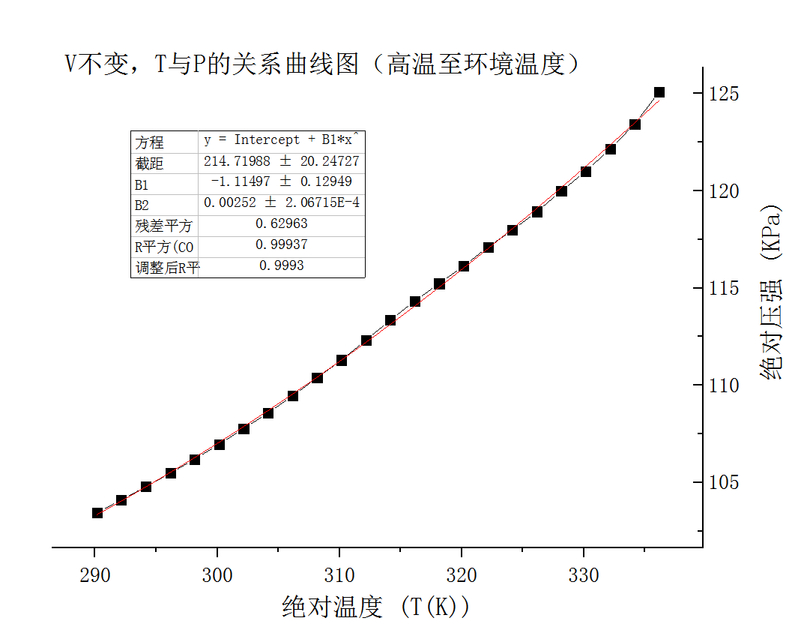
高温到低温

